B.sai teja 2303A510D1
Lab 1

- Downloaded the GitHub Copilot extension in vscode

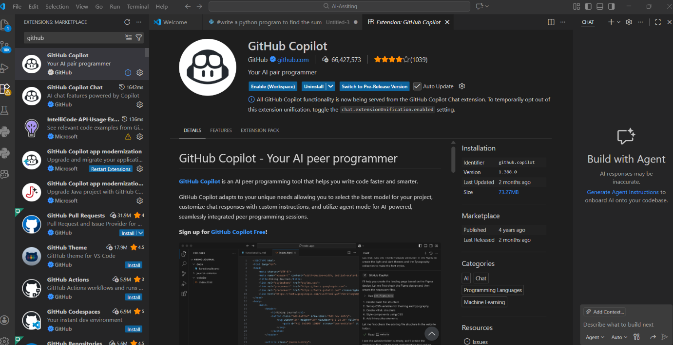

- Downloaded the Python Extension pack in vscode

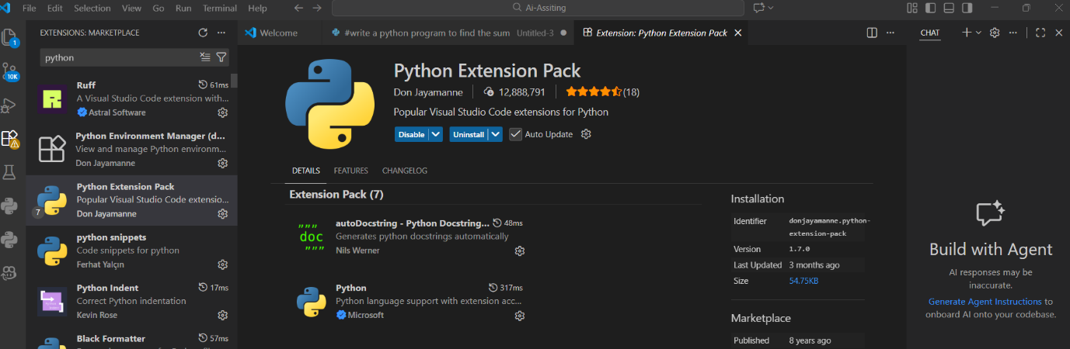

- Implementation of code with the extension pack

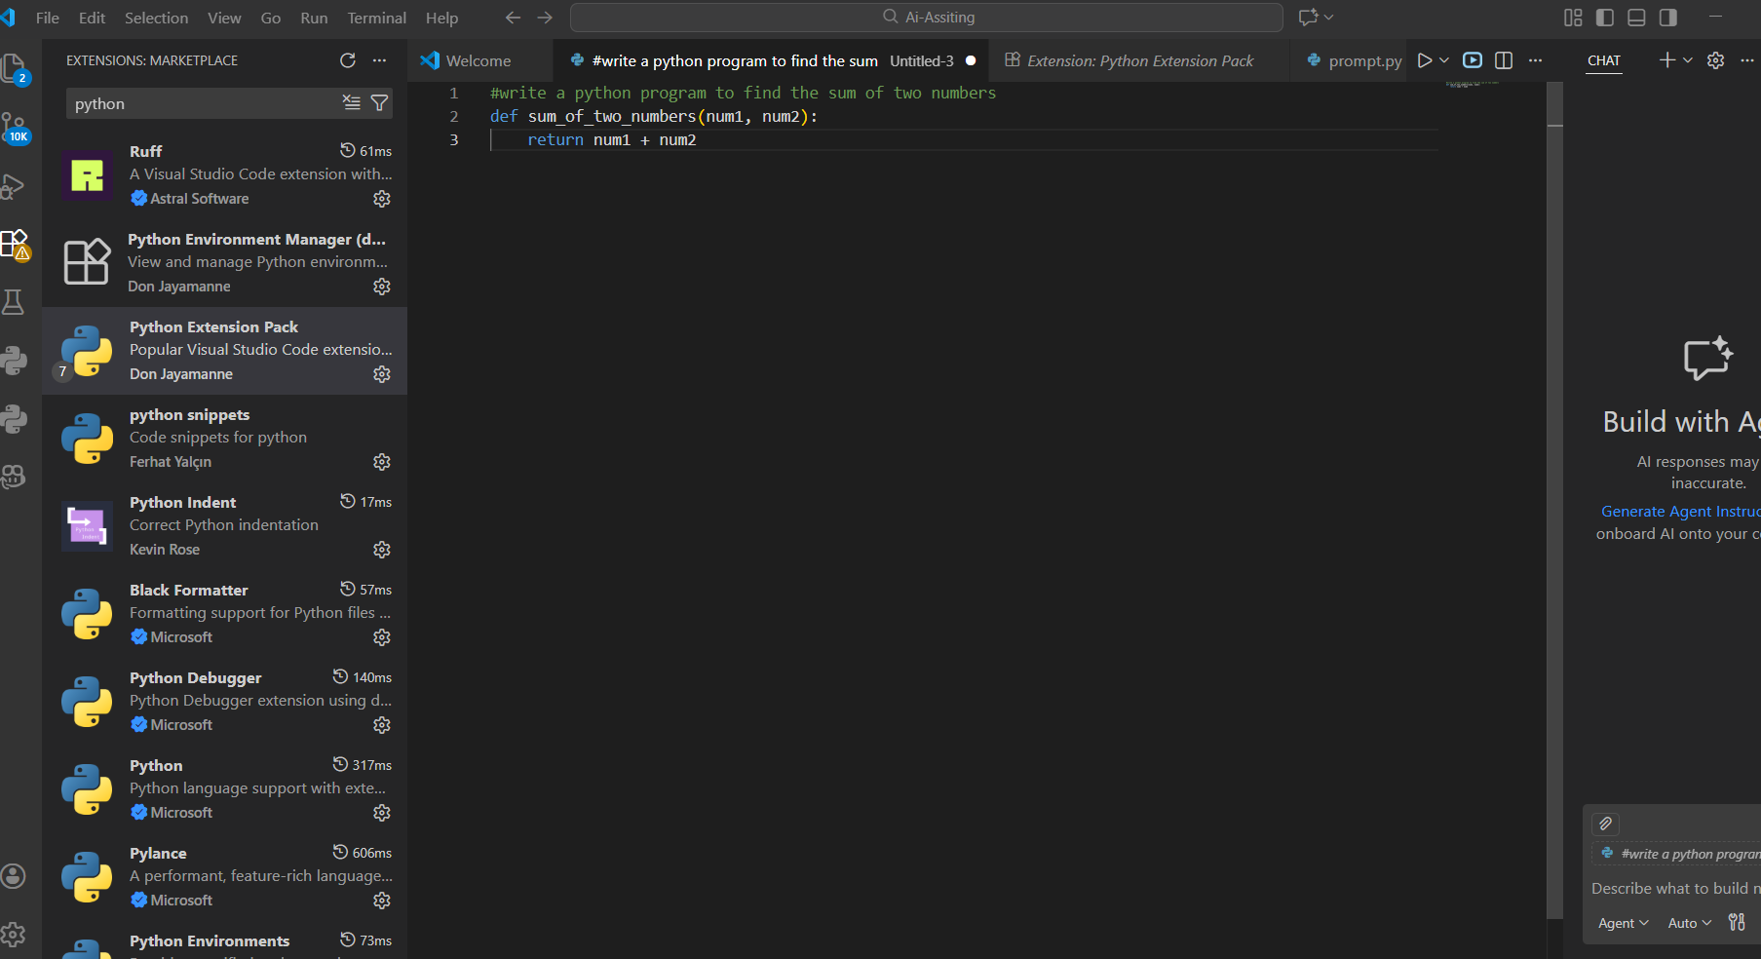

- Implementation of code using github copilot extension

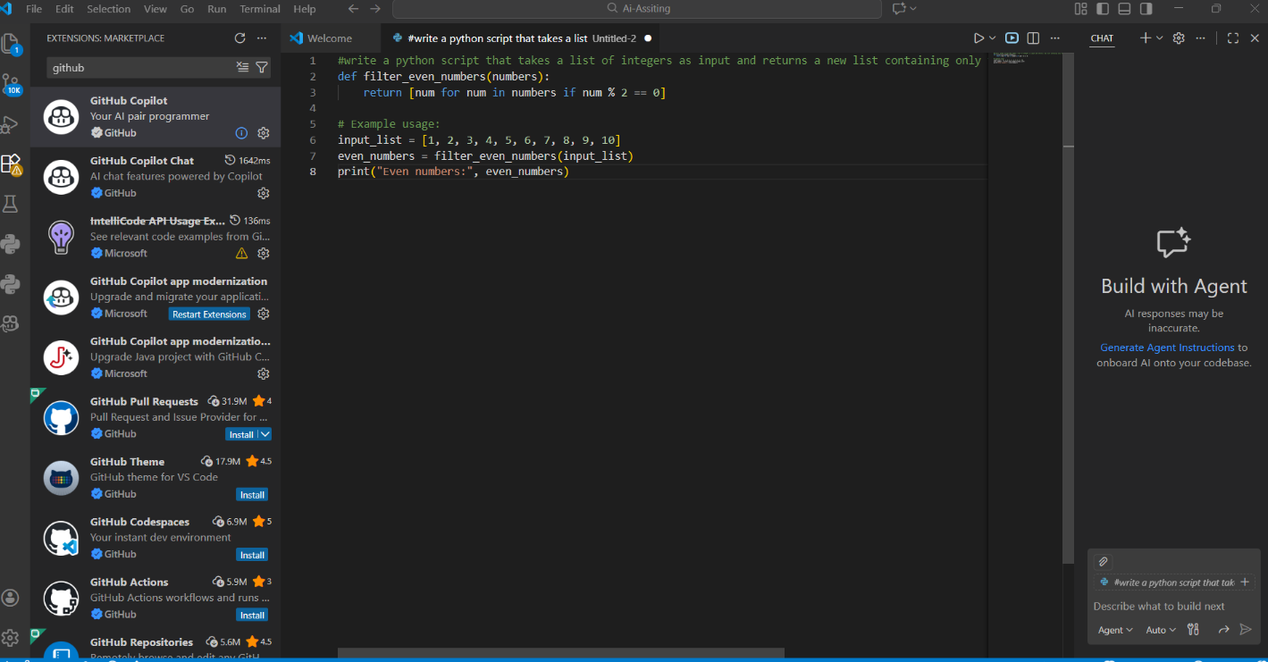

- You are asked to write a quick numerical sequence generator for a learning platform prototype.
Fibonacci series 5 steps

Task 1: AI-Generated Logic Without Modularization (Fibonacci Sequence Without Functions)

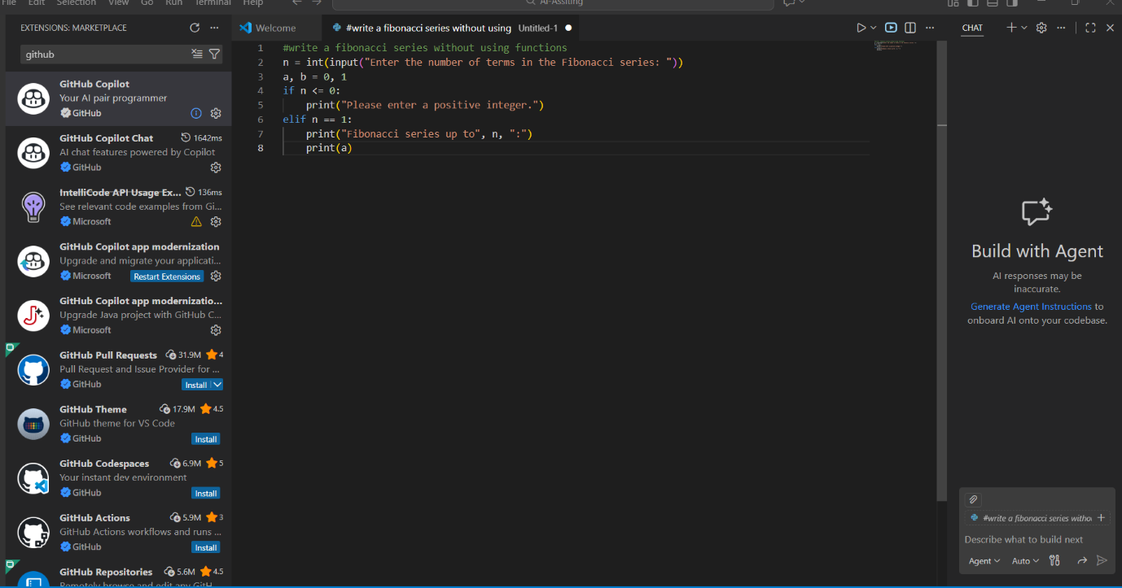

#output for the code of fibonacci series with using functions

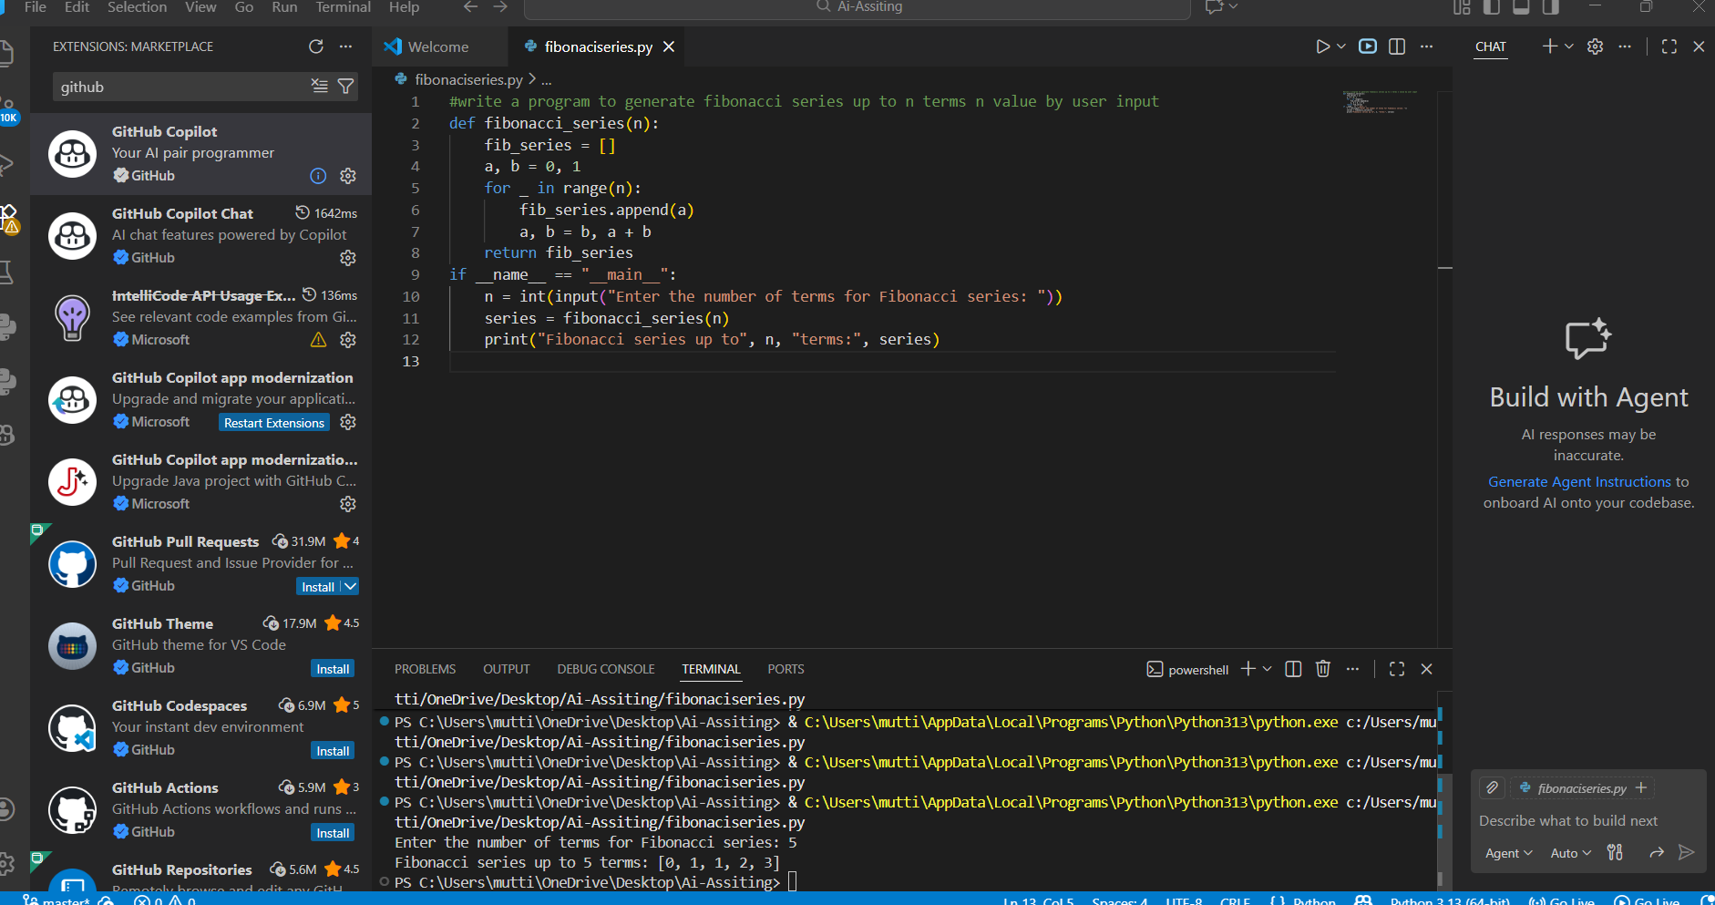

Task 2: AI Code Optimization & Cleanup (Improving Efficiency)

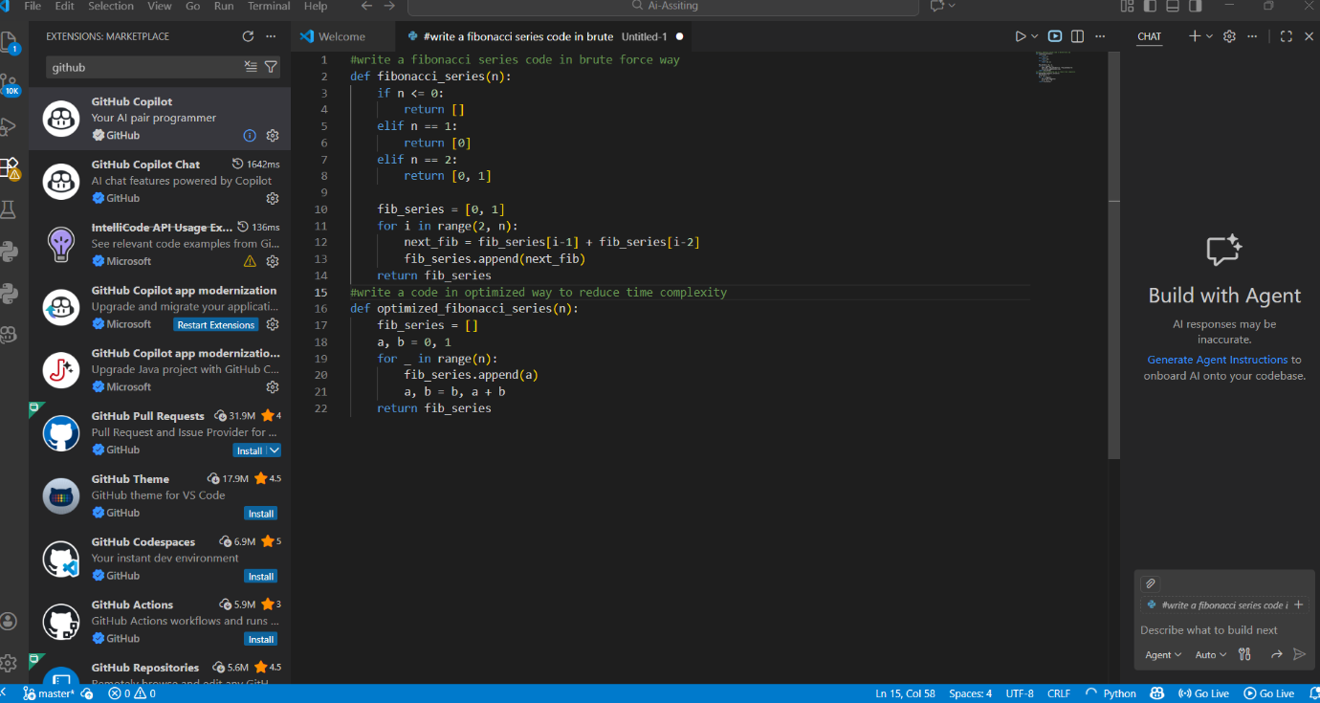

Task 3: Modular Design Using AI Assistance (Fibonacci Using Functions)

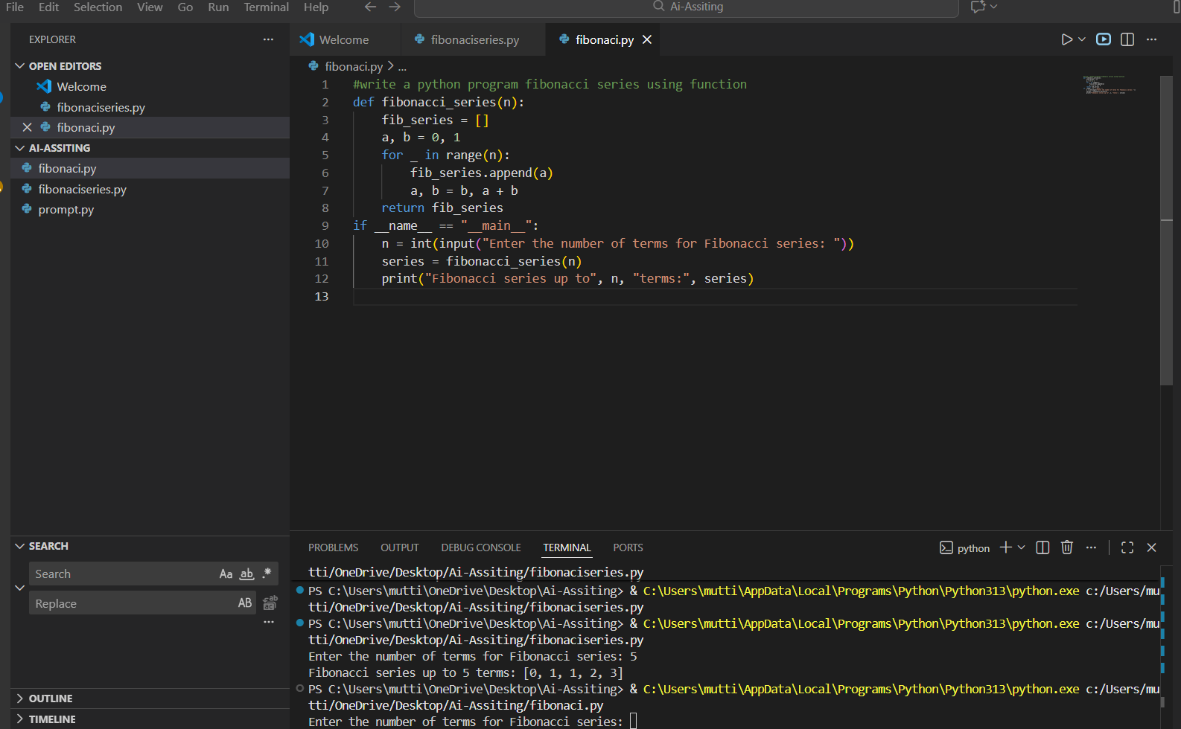

Task 4: Comparative Analysis – Procedural vs Modular Fibonacci Code
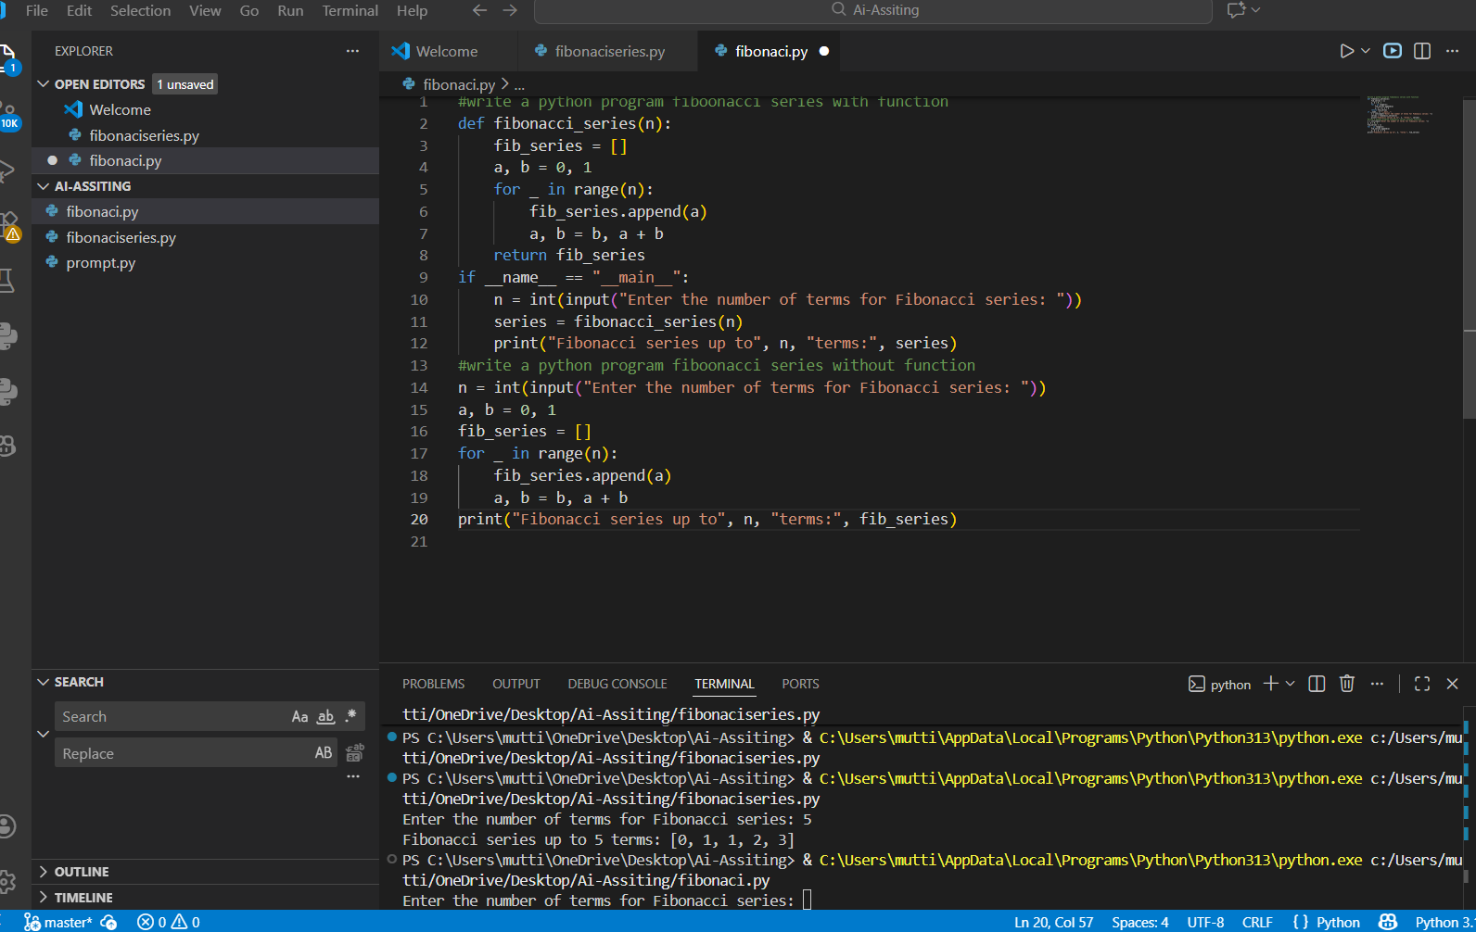

Task 5: AI-Generated Iterative vs Recursive Fibonacci Approaches (Different Algorithmic Approaches for Fibonacci Series)

